Recursive Biological and Adaptive Operational Systems and Admissibility-Preserving Functional Continuity Architectures
Layer 3 Provisional Patent

Field of the Invention
The present disclosure relates generally to:
- biological modeling systems,
- adaptive computational systems,
- recursive operational continuity systems,
- recursive biological traversal systems,
- recursive transfer systems,
- evolutionary modeling systems,
- recursive world-model systems,
- lawful transformational architectures,
- recursive functional continuity systems,
- recursive biological abstraction systems,
- adaptive planning systems,
- and recursively organized operational infrastructures.
More specifically, the disclosure relates to:
- recursive biological traversal,
- functional admissibility preservation,
- recursive evolutionary continuity,
- recursive operational persistence,
- recursive transfer compatibility,
- recursively admissible biological pathways,
- recursive adaptive operational systems,
- recursive functional neighborhood organization,
- recursively induced biological geometry,
- and recursively scalable adaptive computational architectures.
The disclosed systems may operate within:
- biological systems,
- protein systems,
- genetic systems,
- evolutionary systems,
- adaptive AI systems,
- robotics systems,
- transfer-learning systems,
- simulation systems,
- reinforcement-learning systems,
- recursive planning systems,
- adaptive world-model systems,
- or recursively organized lawful adaptive substrates.
Although numerous embodiments described herein reference biological systems, adaptive biological traversal, and evolutionary organization, the disclosed recursive operational continuity systems are not limited to biological domains and may operate across computational, robotic, planning, simulation, world-model, autonomous-agent, or recursively adaptive operational systems.

Background of the Invention
Conventional biological and adaptive computational systems frequently model similarity without preserving lawful operational continuity.
In many existing systems:
- biological representations are generated statistically,
- embeddings preserve similarity without preserving lawful biological traversal,
- transfer systems fail despite representational similarity,
- and abstraction destroys meaningful operational continuity.
Similarly, many adaptive artificial intelligence systems:
- optimize latent similarity independently from lawful traversal continuity,
- compress adaptive structure without preserving operational reachability,
- or reconstruct operational continuity statistically after representation formation.
As adaptive systems scale:
- independently reconstructable relationships increase rapidly,
- adaptive traversal spaces become combinatorially large,
- transfer compatibility becomes unstable,
- and abstraction increasingly destroys lawful operational continuity.
Existing biological and adaptive systems frequently fail to preserve:
- lawful mutation continuity,
- recursive functional neighborhoods,
- recursive operational persistence,
- recursive traversal continuity,
- recursive compatibility structure,
- or recursively admissible transformational continuity.
Likewise, existing transfer systems often:
- treat similarity as compatibility,
- fail to preserve lawful operational continuity during transfer,
- or compress adaptive structure while destroying lawful traversal systems.
Accordingly, there exists a need for systems capable of:
- preserving lawful biological operational continuity,
- recursively organizing functional traversal systems,
- preserving recursive adaptive continuity during abstraction,
- preserving lawful transfer compatibility,
- and inducing stable operational geometry across adaptive abstraction scales.
There further exists a need for systems in which:
- recursively preserved operational structure remains active during later adaptive stages,
- recursively admissible traversal constrains future adaptive organization,
- and recursively meaningful adaptive continuity preserves lawful operational functionality during scaling and transfer.

Core Architectural Thesis
The present disclosure introduces recursive biological and adaptive operational systems in which:
- lawful transformational continuity governs adaptive organization,
- recursively admissible traversal preserves functional continuity,
- recursively organized neighborhoods induce stable operational geometry,
- and recursively preserved operational structure remains active across recursive adaptive scales.
Unlike conventional biological and adaptive systems that:
- optimize similarity independently from operational continuity,
- reconstruct adaptive structure statistically,
- or compress biological organization without preserving lawful traversal continuity,
the disclosed systems:
- preserve lawful operational continuity during adaptive transformation,
- recursively preserve admissibility relationships,
- preserve recursive traversal continuity during abstraction and transfer,
- and induce operational geometry from recursively admissible transformational structure.
Biological systems are presented as naturally occurring embodiments of recursively admissible operational continuity. However, the disclosed architectures are not limited to biological implementations and may operate across substantially different lawful adaptive systems preserving recursively admissible transformational continuity.
In various embodiments:
- recursive biological traversal preserves lawful mutation continuity,
- recursively admissible adaptive systems preserve functional reachability,
- recursively induced operational geometry preserves adaptive continuity during scaling,
- and recursively preserved operational structure constrains future adaptive organization.
In some embodiments:
- adaptive continuity emerges from recursively preserved admissible transformational structure rather than statistical similarity alone,
- recursively meaningful adaptive abstraction preserves lawful operational continuity,
- and recursively scalable adaptive systems emerge from recursive operational persistence across abstraction scales.

Summary of the Invention
The present disclosure provides systems and methods for:
- recursive biological traversal systems,
- recursive adaptive operational systems,
- functional admissibility-preserving architectures,
- recursive evolutionary continuity systems,
- recursive transfer-preserving adaptive infrastructures,
- recursive functional neighborhood systems,
- recursively induced biological operational geometry,
- recursive adaptive abstraction systems,
- and recursively scalable lawful adaptive computation.
In various embodiments:
- recursive biological traversal preserves lawful functional continuity,
- recursively admissible adaptive systems preserve lawful operational reachability,
- recursively meaningful adaptive abstraction preserves lawful traversal continuity,
- and recursively organized operational continuity constrains future adaptive organization.
In some embodiments:
- recursive functional neighborhoods preserve lawful biological continuity,
- recursively preserved operational structure remains computationally active during later adaptive stages,
- recursively induced operational geometry preserves lawful adaptive continuity during scaling,
- and recursively admissible traversal systems preserve meaningful transfer compatibility.
Unlike conventional similarity-based systems:
- statistical similarity alone does not determine operational compatibility,
- latent proximity alone does not preserve lawful adaptive continuity,
- and lawful transformational continuity governs meaningful adaptive organization.
In various embodiments:
- recursively preserved operational continuity reduces independently reconstructable adaptive relationships,
- recursively organized lawful adaptive systems improve transfer stability,
- recursively admissible traversal preserves lawful evolutionary continuity,
- and recursively scalable operational geometry supports adaptive lawful computation across biological and computational domains.
The disclosed systems may operate over:
- biological substrates,
- protein systems,
- evolutionary systems,
- recursive adaptive substrates,
- world-model systems,
- robotic systems,
- reinforcement-learning systems,
- simulation systems,
- or recursively organized lawful adaptive state spaces

Figures

Figure Descriptions

Figure 1 — Recursive Biological Traversal System
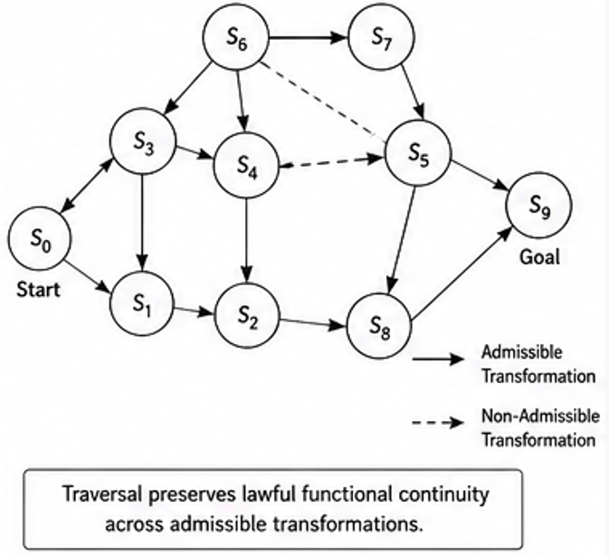
Figure 1 illustrates recursive biological traversal operating over lawful biological transformational substrates.
In some embodiments:
- recursively admissible biological transformations preserve lawful functional continuity,
- recursively organized biological neighborhoods preserve operational reachability,
- and recursively induced biological geometry preserves lawful traversal continuity across recursive biological abstraction scales.
Figure 1 may illustrate:
- mutation traversal pathways,
- recursive biological neighborhoods,
- admissible biological transformations,
- recursive functional continuity,
- or recursively preserved biological operational structure.

Figure 2 — Functional Neighborhood Preservation System
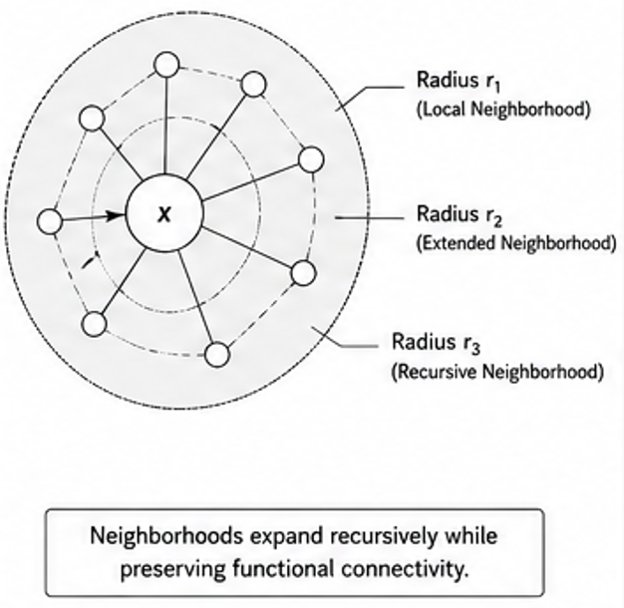
Figure 2 illustrates preservation of recursive functional neighborhood continuity during biological and adaptive abstraction.
In some embodiments:
- recursively meaningful abstraction preserves lawful functional continuity,
- recursively admissible traversal preserves operational biological accessibility,
- and recursively organized functional neighborhoods preserve lawful adaptive continuity during scaling.
Figure 2 may further illustrate:
- functional neighborhood systems,
- recursive traversal continuity,
- operational reachability,
- recursive compatibility structure,
- or recursively induced adaptive geometry.

Figure 3 — Recursive Transfer Compatibility Regimes
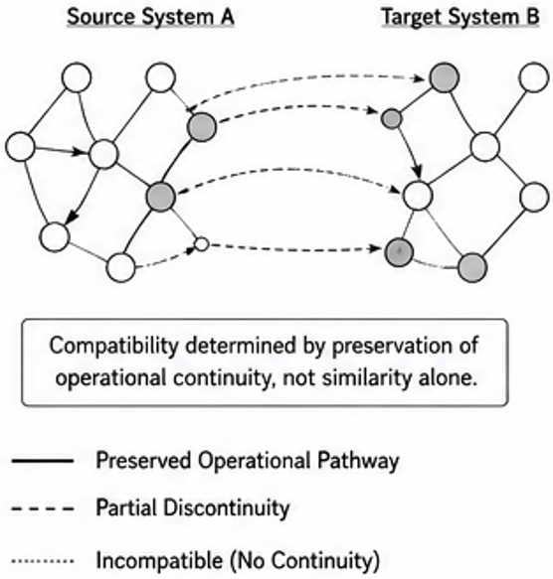
Figure 3 illustrates compatible and incompatible recursive transfer regimes.
In some embodiments:
- transfer compatibility depends on preservation of lawful operational continuity rather than similarity alone,
- recursively admissible traversal preserves lawful compatibility structure,
- and recursively organized operational geometry governs meaningful adaptive transfer continuity.
Figure 3 may illustrate:
- compatible transfer systems,
- incompatible transfer systems,
- recursive compatibility gradients,
- recursive operational continuity,
- or recursively admissible transfer pathways.

Figure 4 — Recursive Mutation Geometry System
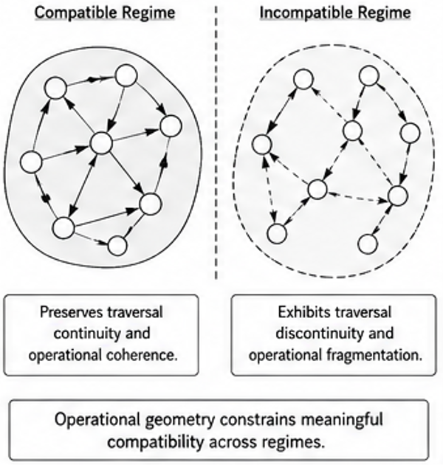
Figure 4 illustrates recursively admissible mutation traversal operating over lawful biological geometry.
In some embodiments:
- recursively admissible mutation systems preserve lawful functional continuity,
- recursively preserved operational structure constrains future biological transformations,
- and recursively induced biological geometry preserves lawful adaptive organization across recursive scales.
Figure 4 may illustrate:
- mutation neighborhoods,
- recursive mutation pathways,
- operational geodesics,
- recursive biological traversal continuity,
- or recursively organized biological geometry.

Figure 5 — Recursive Evolutionary Continuity System
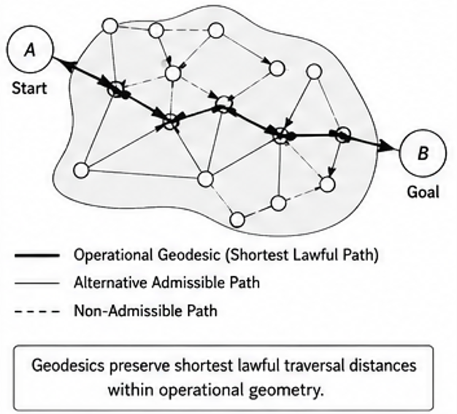
Figure 5 illustrates recursive preservation of lawful operational continuity across evolutionary abstraction scales.
In some embodiments:
- recursively admissible biological traversal preserves lawful evolutionary continuity,
- recursively meaningful adaptive abstraction preserves functional continuity,
- and recursively organized operational geometry preserves meaningful adaptive organization during scaling and transfer.
Figure 5 may further illustrate:
- recursive evolutionary pathways,
- adaptive operational persistence,
- recursive biological reachability,
- recursive hierarchy continuity,
- or recursively admissible evolutionary structure.

Figure 6 — Adaptive Operational System Architecture
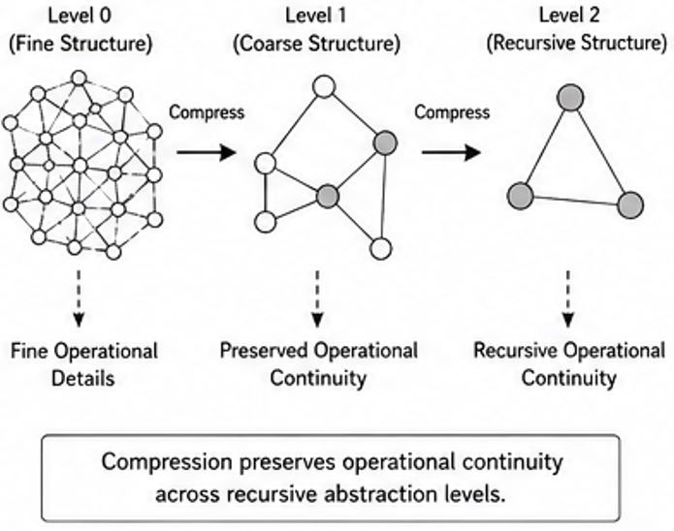
Figure 6 illustrates recursively organized adaptive operational systems preserving lawful operational continuity during planning, traversal, abstraction, and transfer.
In some embodiments:
- recursively admissible traversal constrains adaptive planning trajectories,
- recursively meaningful adaptive abstraction preserves lawful operational continuity,
- and recursively induced geometry preserves scalable adaptive organization across recursive abstraction scales.
Figure 6 may illustrate:
- adaptive planning systems,
- recursive navigation systems,
- recursive operational persistence,
- recursive transfer continuity,
- or recursively admissible adaptive operational structure.

Figure 7 — Recursive Biological Compression Stack
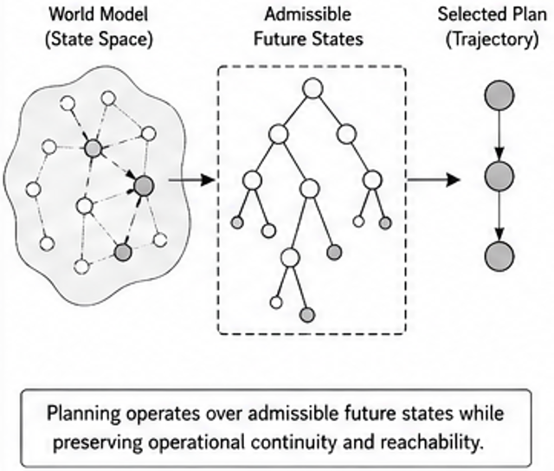
Figure 7 illustrates recursive biological compression preserving lawful operational continuity across biological abstraction levels.
In some embodiments:
- recursively meaningful biological abstraction preserves lawful functional continuity,
- recursively preserved biological operational structure remains active during abstraction,
- and recursively induced biological geometry preserves lawful biological continuity during recursive scaling.
Figure 7 may illustrate:
- recursive biological hierarchy systems,
- recursive biological abstraction layers,
- functional continuity preservation,
- recursive mutation compression,
- recursive operational persistence,
- or recursively admissible biological compression continuity.

Figure 8 — Recursive Transfer Capacity Threshold Curves
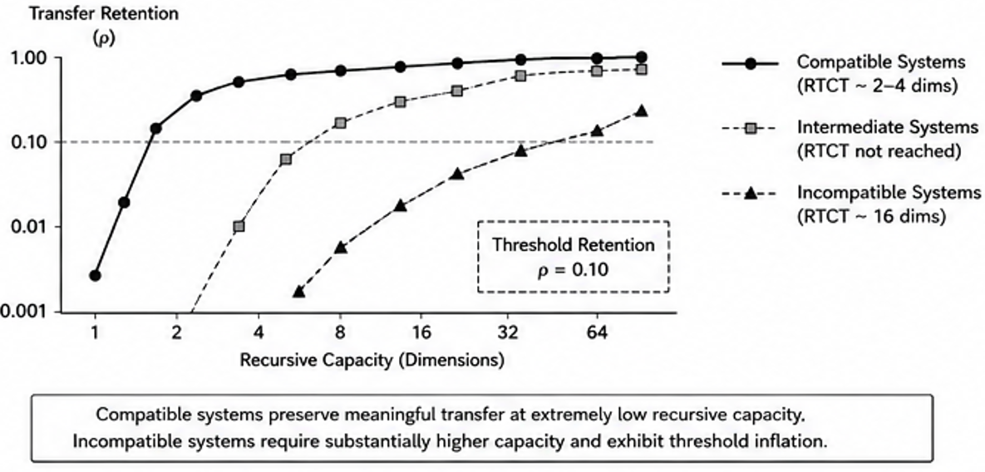
Figure 8 illustrates Recursive Transfer Capacity Threshold (RTCT) behavior across compatible, intermediate, and incompatible adaptive systems.
In some embodiments:
  - recursively admissible transport organization preserves meaningful transfer continuity at low recursive dimensional capacity,
  - recursively meaningful abstraction preserves lawful transfer continuity during compression,
  - and recursively induced transport geometry governs recursive capacity efficiency across adaptive transfer systems.
Figure 8 may illustrate:
  - recursive transfer-capacity curves,
  - compatible and incompatible transfer regimes,
  - recursive dimensional efficiency,
  - recursive capacity inflation,
  - transport-stability thresholds,
  - recursive transfer continuity,
  - or recursively admissible transport organization.

Figure 9 — Transport Fragmentation Boundary Diagram
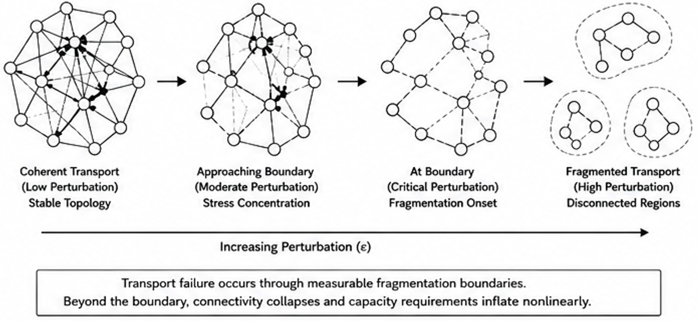
Figure 9 illustrates transport fragmentation boundaries emerging during perturbation-sensitive adaptive traversal.
In some embodiments:
  - recursively admissible transport preserves lawful operational continuity under perturbation,
  - recursively preserved transport organization constrains fragmentation onset,
  - and recursively induced transport geometry governs nonlinear transport destabilization across adaptive systems.
Figure 9 may illustrate:
  - coherent transport systems,
  - stress concentration regions,
  - fragmentation-boundary transitions,
  - disconnected transport regions,
  - recursive transport collapse,
  - recursive perturbation sensitivity,
  - or recursively admissible transport continuity.

Figure 10 — Topology-Defined Adaptive Phase Map
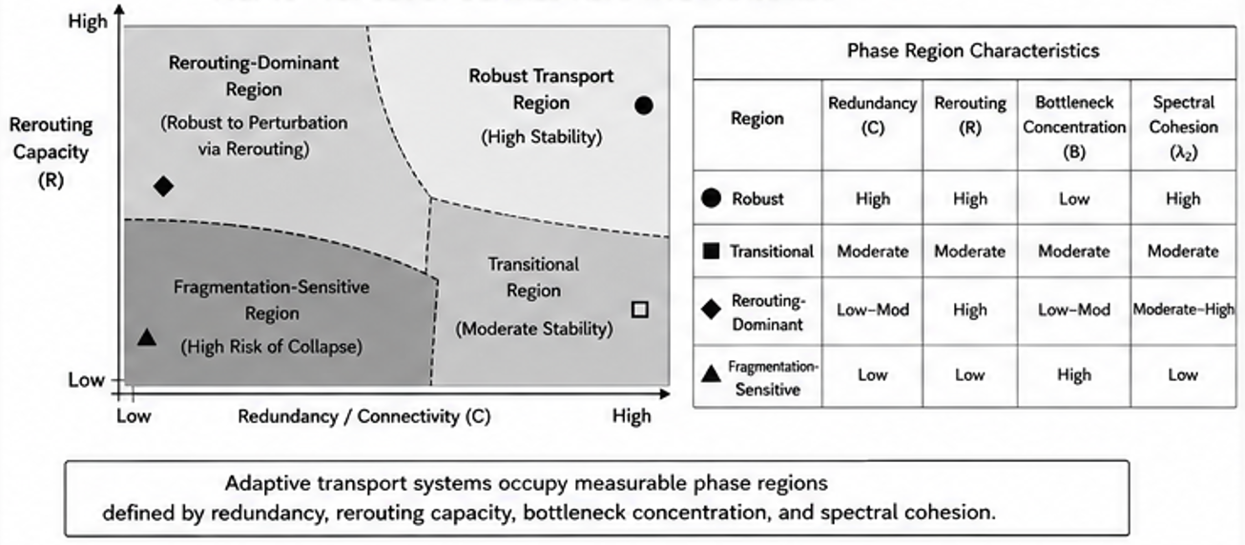
Figure 10 illustrates topology-defined adaptive phase regions organized according to redundancy, rerouting capacity, bottleneck concentration, and spectral cohesion.
In some embodiments:
  - recursively admissible transport organization preserves robust adaptive continuity within stable phase regions,
  - recursively meaningful abstraction preserves lawful transport continuity across adaptive phase transitions,
  - and recursively induced geometry governs measurable adaptive transport behavior.
Figure 10 may illustrate:
  - robust transport regions,
  - rerouting-dominant regions,
  - fragmentation-sensitive regions,
  - transitional adaptive regions,
  - recursive transport topology,
  - recursive spectral cohesion,
  - or recursively admissible adaptive phase organization.

Figure 11 — Causal Topology Intervention Architecture
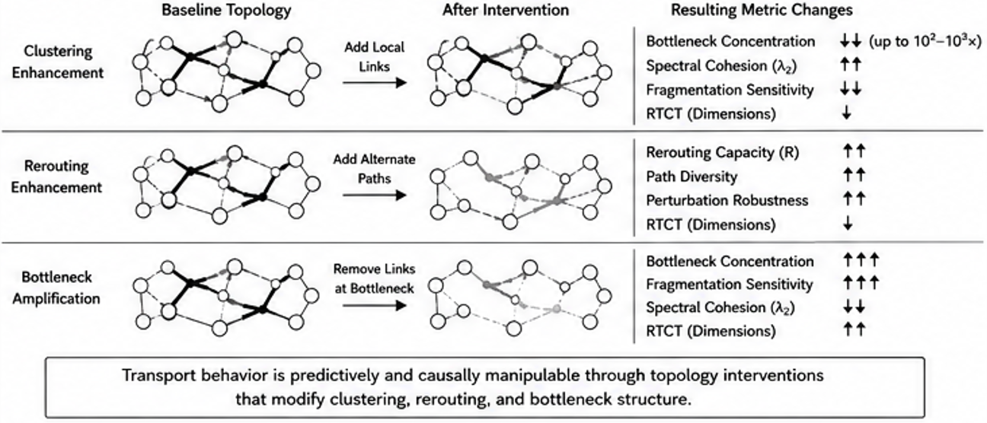
Figure 11 illustrates causal topology intervention systems configured to manipulate adaptive transport behavior through recursive topology restructuring.
In some embodiments:
  - clustering enhancement preserves lawful transport continuity,
  - rerouting enhancement improves recursive operational accessibility,
  - bottleneck amplification increases fragmentation sensitivity,
  - and recursively induced topology governs adaptive transport stability behavior.
Figure 11 may illustrate:
  - clustering-enhancement systems,
  - rerouting-enhancement systems,
  - bottleneck amplification systems,
  - recursive transport stabilization,
  - recursive topology restructuring,
  - spectral stabilization systems,
  - or recursively admissible transport intervention architectures.

Recursive Biological Continuity Framework
In some embodiments:
$B^{\left(k+1\right)}=F\left(B^{\left(k\right)},A^{\left(k\right)},T^{\left(k\right)},S\right)$
where:
- $B^{\left(k\right)}$ represents biological operational structure,
- $A^{\left(k\right)}$ represents admissibility structure,
- $T^{\left(k\right)}$ represents traversal continuity,
- $S$ represents substrate organization,
- and $F$ represents a recursive biological continuity operator.
In some embodiments:
- recursively admissible biological traversal preserves lawful functional continuity,
- recursively organized biological neighborhoods preserve operational reachability,
- and recursively induced biological geometry preserves adaptive continuity across recursive abstraction scales.

Recursive Adaptive Operational Continuity
In some embodiments:
- recursively preserved adaptive operational structure remains active during abstraction, transfer, planning, and evolutionary organization.
Recursive adaptive continuity may preserve:
- recursive traversal continuity,
- recursive functional reachability,
- recursive operational persistence,
- recursive transfer continuity,
- recursive hierarchy organization,
- or recursively admissible adaptive transformational continuity.
In some embodiments:
- recursively meaningful adaptive abstraction preserves lawful operational continuity,
- recursively organized adaptive systems preserve lawful traversal structure,
- and recursively induced operational geometry preserves scalable adaptive organization across recursive scales.

Core Definitions

Recursive Biological Traversal
Recursive biological traversal refers to lawful biological transformation preserving functional continuity across recursive biological abstraction scales.
Recursive biological traversal may preserve:
- lawful mutation continuity,
- recursive biological reachability,
- recursive functional neighborhoods,
- recursive operational persistence,
- recursive evolutionary continuity,
- or recursively admissible biological pathways.
In some embodiments:
- recursively admissible biological traversal preserves lawful functional continuity,
- recursively organized biological neighborhoods preserve operational reachability,
- and recursively induced biological geometry preserves meaningful biological continuity during scaling and transfer.

Functional Admissibility
Functional admissibility refers to lawful transformational compatibility preserving operational functionality during biological or adaptive traversal.
Functional admissibility may preserve:
- lawful biological continuity,
- recursive operational compatibility,
- recursive mutation continuity,
- recursive traversal reachability,
- recursive adaptive persistence,
- or recursively admissible transformational organization.
In some embodiments:
- recursively admissible transformations preserve lawful functionality during adaptive organization,
- recursively meaningful abstraction preserves operational continuity,
- and recursively induced geometry constrains lawful adaptive traversal systems.

Recursive Functional Neighborhood
A recursive functional neighborhood comprises a recursively organized region preserving lawful operational continuity during biological or adaptive transformation.
Recursive functional neighborhoods may preserve:
- functional continuity,
- recursive biological accessibility,
- recursive operational compatibility,
- recursive adaptive persistence,
- recursive traversal continuity,
- or recursively admissible transformational structure.
In some embodiments:
- recursively organized neighborhoods preserve lawful biological continuity,
- recursively meaningful adaptive abstraction preserves operational compatibility,
- and recursively induced operational geometry preserves meaningful adaptive continuity across recursive scales.

Recursive Transfer Compatibility
Recursive transfer compatibility refers to preservation of lawful operational continuity across biological or adaptive transfer systems.
Recursive transfer compatibility may preserve:
- recursive traversal continuity,
- recursive functional compatibility,
- recursive neighborhood continuity,
- recursive operational geometry,
- recursive adaptive persistence,
- or recursively admissible transformational continuity.
In some embodiments:
- recursively preserved operational continuity governs transfer stability,
- recursively admissible traversal preserves lawful compatibility structure,
- and recursively induced geometry preserves meaningful adaptive transfer continuity.
In some embodiments:
- statistical similarity alone does not determine transfer compatibility.

Recursive Evolutionary Continuity
Recursive evolutionary continuity refers to preservation of lawful operational functionality across recursive biological and adaptive evolutionary organization.
Recursive evolutionary continuity may preserve:
- recursive functional persistence,
- recursive biological traversal,
- recursive mutation continuity,
- recursive hierarchy organization,
- recursive adaptive continuity,
- or recursively admissible evolutionary pathways.
In some embodiments:
- recursively admissible biological traversal preserves lawful evolutionary continuity,
- recursively meaningful adaptive abstraction preserves functional continuity,
- and recursively induced operational geometry preserves meaningful evolutionary organization across recursive scales.

Adaptive Operational Persistence
Adaptive operational persistence refers to recursively preserved operational structure remaining active during adaptive abstraction, planning, transfer, or evolution.
Adaptive operational persistence may preserve:
- recursive operational continuity,
- recursive traversal systems,
- recursive functional continuity,
- recursive planning organization,
- recursive adaptive reachability,
- or recursively admissible transformational persistence.
In some embodiments:
- recursively meaningful abstraction preserves lawful adaptive continuity,
- recursively organized adaptive systems preserve operational persistence during scaling,
- and recursively induced operational geometry preserves meaningful adaptive organization across recursive abstraction levels.

Recursive Biological Geometry
Recursive biological geometry refers to operational geometry induced from recursively admissible biological transformational continuity.
Recursive biological geometry may preserve:
- lawful mutation pathways,
- recursive biological reachability,
- recursive operational geodesics,
- recursive neighborhood continuity,
- recursive adaptive persistence,
- or recursively admissible biological traversal systems.
In some embodiments:
- recursively admissible biological traversal induces lawful operational geometry,
- recursively meaningful biological abstraction preserves functional continuity,
- and recursively induced geometry preserves meaningful biological organization across recursive scales.

Recursive Adaptive Geometry
Recursive adaptive geometry refers to operational geometry induced from recursively admissible adaptive traversal continuity.
Recursive adaptive geometry may preserve:
- recursive operational continuity,
- recursive planning continuity,
- recursive navigation organization,
- recursive adaptive reachability,
- recursive transfer continuity,
- or recursively admissible adaptive transformational systems.
In some embodiments:
- recursively meaningful adaptive abstraction preserves lawful operational continuity,
- recursively organized adaptive systems preserve meaningful traversal structure,
- and recursively induced geometry preserves scalable adaptive operational organization.

Recursive Compatibility Regime
A recursive compatibility regime comprises a region of biological or adaptive organization preserving lawful operational continuity during transfer, traversal, or abstraction.
Recursive compatibility regimes may preserve:
- recursive transfer stability,
- recursive traversal continuity,
- recursive functional reachability,
- recursive operational persistence,
- recursive neighborhood organization,
- or recursively admissible compatibility systems.
In some embodiments:
- recursively admissible traversal preserves lawful compatibility continuity,
- recursively meaningful abstraction preserves operational compatibility,
- and recursively induced geometry constrains meaningful adaptive transfer pathways.

Recursive Functional Compression
Recursive functional compression refers to adaptive abstraction preserving lawful functional continuity during recursive scaling.
Recursive functional compression may preserve:
- recursive biological continuity,
- recursive adaptive persistence,
- recursive operational accessibility,
- recursive traversal continuity,
- recursive transfer compatibility,
- or recursively admissible transformational organization.
In some embodiments:
- recursively meaningful adaptive abstraction preserves lawful functionality during scaling,
- recursively organized adaptive systems preserve operational continuity,
- and recursively induced geometry preserves meaningful adaptive organization across recursive abstraction levels.

Recursive Adaptive Reachability
Recursive adaptive reachability refers to preservation of lawful adaptive accessibility relationships across recursive abstraction scales.
Recursive adaptive reachability may preserve:
- lawful future-state continuity,
- recursive planning accessibility,
- recursive operational continuity,
- recursive traversal coherence,
- recursive adaptive persistence,
- or recursively admissible trajectory organization.
In some embodiments:
- recursively admissible traversal preserves lawful adaptive accessibility,
- recursively meaningful abstraction preserves operational continuity,
- and recursively induced geometry preserves meaningful adaptive navigation structure during scaling.

Recursive Biological Operational Continuity
Recursive biological operational continuity refers to preservation of lawful biological operational structure across recursive abstraction, transfer, and evolutionary organization.
Recursive biological operational continuity may preserve:
- recursive biological traversal,
- recursive functional continuity,
- recursive operational persistence,
- recursive mutation organization,
- recursive adaptive continuity,
- or recursively admissible biological transformational structure.
In some embodiments:
- recursively meaningful biological abstraction preserves lawful functional continuity,
- recursively preserved biological operational structure remains active during abstraction,
- and recursively induced biological geometry preserves meaningful biological organization across recursive scales.

Recursive Adaptive World-Model Continuity
Recursive adaptive world-model continuity refers to preservation of lawful operational continuity during recursive future-state planning and adaptive traversal.
Recursive adaptive world-model continuity may preserve:
- recursive planning continuity,
- recursive future-state reachability,
- recursive navigation structure,
- recursive operational persistence,
- recursive trajectory continuity,
- or recursively admissible future-state organization.
In some embodiments:
- recursively admissible traversal constrains future-state planning,
- recursively meaningful adaptive abstraction preserves lawful predictive continuity,
- and recursively induced geometry preserves meaningful adaptive planning organization during scaling.

Recursive Transport Topology
operational transport structure induced from recursively admissible traversal continuity across multiscale adaptive systems.

Recursive Transfer Capacity Threshold (RTCT)
minimum recursive representational capacity required to preserve lawful transfer continuity between adaptive systems.

Transport Fragmentation Boundary
a perturbation-sensitive operational transition separating coherent and fragmented transport organization.

Topology-Defined Adaptive Phase Region
an operational regime characterized by measurable transport stability properties governed by redundancy, bottleneck concentration, rerouting capacity, and spectral cohesion.

Recursive Transport Stabilization
preservation of coherent multiscale transport continuity during recursive abstraction and perturbation.

Recursive Biological Traversal Systems

Recursive Biological Traversal Systems
The present disclosure introduces recursive biological traversal systems in which:
- lawful biological transformations preserve operational functionality,
- recursively admissible biological traversal constrains future biological organization,
- and recursively preserved operational continuity remains active across recursive biological abstraction scales.
Unlike conventional biological modeling systems that:
- organize biological structure statistically,
- optimize similarity independently from lawful biological continuity,
- or reconstruct biological operational structure after representation formation,
the disclosed systems:
- preserve lawful biological traversal continuity during transformation,
- recursively preserve admissibility relationships,
- preserve recursive functional continuity during abstraction and transfer,
- and induce biological operational geometry from recursively admissible transformational continuity.
In various embodiments:
- recursive biological traversal preserves lawful mutation continuity,
- recursively organized biological neighborhoods preserve functional reachability,
- recursively induced biological geometry preserves lawful biological organization during scaling,
- and recursively preserved biological operational structure constrains future adaptive organization.

Functional Biological Continuity
In some embodiments:
- biological functionality is preserved through recursively admissible transformational continuity rather than statistical similarity alone.
Functional biological continuity may preserve:
- lawful mutation continuity,
- recursive functional neighborhoods,
- recursive operational persistence,
- recursive biological reachability,
- recursive adaptive continuity,
- or recursively admissible biological transformational organization.
In some embodiments:
- recursively admissible biological traversal preserves lawful functionality,
- recursively meaningful biological abstraction preserves operational continuity,
- and recursively induced biological geometry preserves meaningful biological organization during scaling and transfer.

Recursive Mutation Systems
In some embodiments:
- recursive mutation systems preserve lawful biological continuity during adaptive transformation.
Recursive mutation systems may preserve:
- lawful mutation pathways,
- recursive functional continuity,
- recursive biological accessibility,
- recursive neighborhood continuity,
- recursive operational persistence,
- or recursively admissible biological pathways.
In some embodiments:
- recursively preserved biological operational structure constrains future mutation organization,
- recursively meaningful biological abstraction preserves lawful biological continuity,
- and recursively induced biological geometry preserves meaningful mutation traversal organization across recursive abstraction scales.
Unlike unconstrained mutation systems:
- recursively admissible mutation traversal preserves lawful operational functionality during transformation.

Functional Neighborhood Preservation
In some embodiments:
- recursive biological systems preserve lawful functional neighborhood continuity.
Functional neighborhood preservation may preserve:
- recursive biological continuity,
- recursive operational compatibility,
- recursive mutation accessibility,
- recursive adaptive persistence,
- recursive traversal coherence,
- or recursively admissible biological organization.
In some embodiments:
- recursively organized biological neighborhoods preserve lawful functional continuity,
- recursively meaningful abstraction preserves operational compatibility,
- and recursively induced biological geometry preserves meaningful biological continuity across recursive scales.

Recursive Biological Reachability
In some embodiments:
- recursive biological traversal preserves lawful functional accessibility relationships.
Recursive biological reachability may preserve:
- lawful mutation accessibility,
- recursive functional continuity,
- recursive biological navigation structure,
- recursive operational continuity,
- recursive adaptive persistence,
- or recursively admissible biological trajectory systems.
In some embodiments:
- recursively admissible biological traversal preserves lawful accessibility,
- recursively meaningful biological abstraction preserves operational continuity,
- and recursively induced biological geometry preserves meaningful biological navigation organization during scaling.

Recursive Evolutionary Systems
In some embodiments:
- recursive evolutionary systems preserve lawful operational continuity during adaptive evolutionary organization.
Recursive evolutionary systems may preserve:
- recursive functional continuity,
- recursive mutation organization,
- recursive biological reachability,
- recursive hierarchy continuity,
- recursive adaptive persistence,
- or recursively admissible evolutionary pathways.
In some embodiments:
- recursively admissible biological traversal preserves lawful evolutionary continuity,
- recursively meaningful adaptive abstraction preserves functional continuity,
- and recursively induced biological geometry preserves meaningful evolutionary organization across recursive abstraction scales.

Recursive Biological Operational Persistence
In some embodiments:
- recursively preserved biological operational structure remains active during later adaptive stages.
Recursive biological operational persistence may preserve:
- recursive traversal continuity,
- recursive functional persistence,
- recursive mutation continuity,
- recursive neighborhood organization,
- recursive biological reachability,
- or recursively admissible biological transformational continuity.
In some embodiments:
- recursively meaningful biological abstraction preserves lawful operational continuity,
- recursively organized biological systems preserve operational persistence during scaling,
- and recursively induced biological geometry preserves meaningful biological organization across recursive abstraction levels.

Recursive Functional Compatibility
In some embodiments:
- biological compatibility depends on preservation of lawful operational continuity rather than similarity alone.
Recursive functional compatibility may preserve:
- recursive transfer continuity,
- recursive biological compatibility,
- recursive neighborhood organization,
- recursive operational persistence,
- recursive adaptive reachability,
- or recursively admissible transformational continuity.
In some embodiments:
- recursively preserved operational continuity governs biological compatibility,
- recursively admissible traversal preserves lawful functional transfer structure,
- and recursively induced geometry preserves meaningful adaptive transfer organization.
In some embodiments:
- statistically similar biological systems remain operationally incompatible when lawful traversal continuity is not preserved.

Recursive Biological Abstraction
In some embodiments:
- recursive biological abstraction preserves lawful operational continuity during scaling.
Recursive biological abstraction may preserve:
- recursive functional continuity,
- recursive mutation reachability,
- recursive biological traversal systems,
- recursive operational persistence,
- recursive adaptive continuity,
- or recursively admissible biological transformational structure.
In some embodiments:
- recursively meaningful biological abstraction preserves lawful functionality during scaling,
- recursively organized biological systems preserve operational continuity,
- and recursively induced biological geometry preserves meaningful biological organization across recursive abstraction scales.

Recursive Biological Geometry
In some embodiments:
- operational biological geometry emerges from recursively admissible transformational continuity.
Recursive biological geometry may preserve:
- lawful mutation pathways,
- recursive operational geodesics,
- recursive biological accessibility,
- recursive functional continuity,
- recursive adaptive persistence,
- or recursively admissible biological traversal systems.
In some embodiments:
- recursively admissible biological traversal induces lawful biological geometry,
- recursively meaningful abstraction preserves operational continuity,
- and recursively induced geometry preserves meaningful biological organization during scaling and transfer.

Recursive Transport-Topology Systems, Phase Regions, and Causal Topology Intervention

Recursive Transport-Topology Systems
The present disclosure further introduces recursive transport-topology systems in which:
- admissibility-constrained recursive organization induces multiscale transport geometry,
- recursively admissible traversal preserves lawful transport continuity,
- recursively stabilized transport topology governs transfer compatibility,
- and transport failure emerges through measurable fragmentation boundaries.
Unlike conventional similarity-based biological and adaptive systems that:
- organize states according to local feature similarity,
- optimize embeddings independently from transport continuity,
- or reconstruct operational structure statistically,
the disclosed systems:
- preserve lawful transport continuity during adaptive traversal,
- recursively preserve admissibility-constrained transport structure,
- preserve multiscale transport geometry during abstraction and transfer,
- and induce operational topology from recursively admissible transformational continuity.
In various embodiments:
- recursively admissible traversal preserves transport coherence,
- recursively meaningful abstraction preserves multiscale transport organization,
- recursively induced geometry preserves lawful transfer continuity,
- and recursively preserved transport structure constrains future adaptive organization.

Recursive Transport Topology
Recursive transport topology refers to operational transport structure induced from recursively admissible traversal continuity across multiscale adaptive systems.
Recursive transport topology may preserve:
- recursive transport continuity,
- recursive operational geodesics,
- recursive traversal coherence,
- recursive rerouting accessibility,
- recursive bottleneck organization,
- recursive spectral cohesion,
- or recursively admissible transport pathways.
In some embodiments:
- recursively admissible traversal induces lawful transport topology,
- recursively meaningful abstraction preserves transport continuity,
- and recursively induced geometry preserves scalable adaptive transport organization.

Recursive Transfer Capacity Threshold (Rtct)
A Recursive Transfer Capacity Threshold (RTCT) comprises a minimum recursive representational capacity required to preserve lawful transfer continuity between adaptive systems.
In some embodiments:
- compatible systems preserve meaningful transfer at substantially lower recursive capacity than incompatible systems,
- recursive capacity inflation emerges during fragmentation-sensitive transfer,
- and recursively admissible transport organization preserves efficient low-capacity transfer continuity.
In some embodiments:
- compatible biological systems preserve meaningful transfer using approximately 2–4 recursive dimensions,
- while incompatible systems require substantially higher recursive capacity.
Recursive Transfer Capacity Thresholds may preserve:
- recursive transport efficiency,
- recursive transfer continuity,
- recursive compression stability,
- recursive abstraction continuity,
- or recursively admissible adaptive organization.

Transport Fragmentation Boundaries
A transport fragmentation boundary comprises a perturbation-sensitive operational transition separating coherent and fragmented transport organization.
Transport fragmentation boundaries may preserve or govern:
- recursive transport collapse,
- recursive capacity inflation,
- bottleneck-sensitive destabilization,
- rerouting failure,
- recursive traversal fragmentation,
- or recursively inadmissible transport organization.
In some embodiments:
- compatible systems preserve transport continuity under perturbation,
- incompatible systems exhibit nonlinear transport fragmentation,
- and recursively induced transport geometry governs fragmentation-sensitive adaptive behavior.
In some embodiments:
- transport failure behaves as nonlinear transport fragmentation rather than gradual similarity decay.

Topology-Defined Adaptive Phase Regions
A topology-defined adaptive phase region comprises an operational regime characterized by measurable transport stability properties governed by:
- redundancy,
- bottleneck concentration,
- rerouting capacity,
- spectral cohesion,
- recursive reachability,
- or recursively admissible transport organization.
Topology-defined adaptive phase regions may include:
- robust transport regions,
- transitional transport regions,
- rerouting-dominant regions,
- fragmentation-sensitive regions,
- or recursively stabilized adaptive operational regions.
In some embodiments:
- recursively admissible transport preserves stable operational continuity within robust phase regions,
- recursively meaningful abstraction preserves adaptive continuity across phase transitions,
- and recursively induced geometry governs measurable transport phase behavior.

Recursive Transport Stabilization
Recursive transport stabilization refers to preservation of coherent multiscale transport continuity during recursive abstraction and perturbation.
Recursive transport stabilization may preserve:
- recursive operational continuity,
- recursive transfer stability,
- recursive rerouting continuity,
- recursive bottleneck stabilization,
- recursive spectral cohesion,
- or recursively admissible transport organization.
In some embodiments:
- compatible systems progressively stabilize transport organization across recursive scales,
- recursively meaningful abstraction preserves transport coherence,
- and recursively induced geometry preserves adaptive continuity during perturbation and transfer.

Recursive Rerouting Systems
Recursive rerouting systems preserve lawful operational continuity through alternate admissible transport pathways.
Recursive rerouting systems may preserve:
- recursive transport continuity,
- recursive accessibility,
- recursive planning continuity,
- recursive transfer persistence,
- recursive operational redundancy,
- or recursively admissible alternate traversal systems.
In some embodiments:
- dense redundant transport systems preserve rerouting capacity under perturbation,
- recursively admissible transport pathways preserve operational continuity during fragmentation,
- and recursively induced geometry preserves adaptive continuity through alternate traversal organization.

Bottleneck Topology Systems
Bottleneck topology systems preserve or manipulate operational bottleneck concentration within adaptive transport systems.
Bottleneck topology systems may preserve or manipulate:
- transport stress concentration,
- recursive fragmentation sensitivity,
- recursive traversal congestion,
- recursive accessibility collapse,
- recursive rerouting continuity,
- or recursively admissible transport stability.
In some embodiments:
- bottleneck amplification increases fragmentation sensitivity,
- clustering enhancement reduces bottleneck dominance,
- and recursively induced topology governs transport stability behavior.
In some embodiments:
- clustering enhancement reduces bottleneck dominance by multiple orders of magnitude relative to baseline transport organization.

Spectral Cohesion Systems
Spectral cohesion systems preserve global transport continuity using recursive spectral organization.
Spectral cohesion systems may preserve:
- recursive transport continuity,
- recursive operational connectivity,
- recursive stabilization behavior,
- recursive adaptive persistence,
- recursive phase coherence,
- or recursively admissible transport accessibility.
In some embodiments:
- robust transport systems preserve substantially higher spectral cohesion than fragmentation-sensitive systems,
- recursively meaningful abstraction preserves spectral continuity during scaling,
- and recursively induced geometry preserves adaptive phase stability across recursive transport scales.

Causal Topology Intervention Systems
Causal topology intervention systems manipulate adaptive transport behavior through modification of recursive transport topology.
Causal topology interventions may include:
- redundancy enhancement,
- clustering enhancement,
- rerouting enhancement,
- bottleneck amplification,
- bottleneck reduction,
- spectral stabilization,
- recursive accessibility modification,
- or recursively admissible topology restructuring.
In some embodiments:
- redundancy enhancement improves transport robustness,
- clustering enhancement reduces fragmentation sensitivity,
- bottleneck amplification increases transport destabilization,
- and recursively induced topology governs adaptive transport behavior.
In some embodiments:
- adaptive transport systems are predictively manipulable through recursive topology intervention.

Predictive Transport-Topology Systems
Predictive transport-topology systems infer adaptive stability behavior from recursive transport structure.
Predictive transport-topology systems may predict:
- fragmentation sensitivity,
- perturbation robustness,
- transfer compatibility,
- rerouting persistence,
- recursive accessibility continuity,
- adaptive phase behavior,
- or recursively admissible transport stability.
In some embodiments:
- transport behavior is predictable from recursive topology organization,
- recursively meaningful abstraction preserves predictive transport continuity,
- and recursively induced geometry preserves measurable adaptive phase structure across recursive scales.

Operational Embodiments
In some embodiments:
- compatible biological systems preserve meaningful transfer under extreme recursive compression,
- incompatible systems exhibit recursive capacity inflation and fragmentation-sensitive destabilization,
- dense redundant transport systems preserve rerouting continuity,
- sparse bottleneck-dominant systems exhibit fragmentation-sensitive transport collapse,
- and recursively admissible topology governs measurable adaptive phase behavior.
Example operational metrics may include:
- Recursive Transfer Capacity Thresholds,
- recursive path-fidelity retention,
- recursive transport coherence,
- bottleneck concentration,
- rerouting accessibility,
- geodesic distortion,
- recursive perturbation drift,
- spectral cohesion,
- recursive transfer continuity,
- recursive hierarchy stabilization,
- or recursively admissible transport-preservation metrics.

Recursive Functional Stability
In some embodiments:
- biological stability emerges from recursively preserved admissibility structure rather than statistical stabilization alone.
Recursive functional stability may preserve:
- recursive operational continuity,
- recursive biological traversal,
- recursive neighborhood coherence,
- recursive mutation continuity,
- recursive adaptive persistence,
- or recursively admissible transformational organization.
In some embodiments:
- recursively preserved biological operational continuity constrains future biological organization,
- recursively meaningful abstraction preserves lawful functional continuity,
- and recursively induced biological geometry preserves meaningful adaptive organization across recursive abstraction scales.

Functional Neighborhood and Transfer Compatibility Systems

Functional Neighborhood Systems
The present disclosure introduces functional neighborhood systems in which:
- recursively admissible biological and adaptive transformations preserve lawful operational continuity,
- recursively organized neighborhoods preserve functional accessibility relationships,
- and recursively induced operational geometry preserves meaningful adaptive organization across recursive scales.
Unlike conventional similarity-based neighborhood systems that:
- organize states according to statistical proximity,
- preserve local similarity without preserving lawful traversal continuity,
- or define compatibility independently from operational reachability,
the disclosed systems:
- preserve lawful functional continuity during adaptive traversal,
- recursively preserve operational compatibility relationships,
- preserve lawful biological accessibility during abstraction and transfer,
- and induce operational geometry from recursively admissible transformational continuity.
In various embodiments:
- recursive functional neighborhoods preserve lawful adaptive traversal continuity,
- recursively meaningful abstraction preserves operational compatibility,
- recursively induced operational geometry preserves meaningful transfer continuity,
- and recursively preserved operational structure constrains future adaptive organization.

Functional Neighborhood Continuity
In some embodiments:
- recursive functional neighborhoods preserve lawful operational continuity during adaptive transformation.
Functional neighborhood continuity may preserve:
- recursive traversal continuity,
- recursive operational accessibility,
- recursive mutation continuity,
- recursive adaptive persistence,
- recursive compatibility organization,
- or recursively admissible transformational structure.
In some embodiments:
- recursively admissible traversal preserves lawful neighborhood continuity,
- recursively meaningful abstraction preserves operational compatibility,
- and recursively induced geometry preserves meaningful adaptive organization during scaling and transfer.

Recursive Transfer Compatibility Systems
In some embodiments:
- adaptive transfer compatibility depends on preservation of lawful operational continuity rather than similarity alone.
Recursive transfer compatibility systems may preserve:
- recursive traversal continuity,
- recursive operational compatibility,
- recursive neighborhood continuity,
- recursive adaptive persistence,
- recursive planning continuity,
- or recursively admissible transformational organization.
In some embodiments:
- recursively preserved operational continuity governs transfer stability,
- recursively admissible traversal preserves lawful compatibility pathways,
- and recursively induced geometry preserves meaningful adaptive transfer organization.
Unlike similarity-based transfer systems:
- statistical similarity alone does not determine operational compatibility.

Compatible And Incompatible Transfer Regimes
In some embodiments:
- recursively organized adaptive systems naturally partition into compatible and incompatible operational regimes.
Compatible transfer regimes may preserve:
- lawful traversal continuity,
- recursive operational compatibility,
- recursive functional accessibility,
- recursive planning continuity,
- recursive adaptive persistence,
- or recursively admissible transformational organization.
Incompatible transfer regimes may exhibit:
- operational discontinuity,
- traversal distortion,
- neighborhood incompatibility,
- reachability fragmentation,
- functional instability,
- or recursively inadmissible transformational organization.
In some embodiments:
- recursively admissible traversal preserves lawful compatibility structure,
- recursively meaningful abstraction preserves adaptive continuity,
- and recursively induced geometry constrains meaningful transfer pathways.

Recursive Operational Compatibility
In some embodiments:
- operational compatibility emerges from recursively preserved admissibility structure.
Recursive operational compatibility may preserve:
- recursive transfer continuity,
- recursive traversal coherence,
- recursive neighborhood organization,
- recursive planning accessibility,
- recursive adaptive persistence,
- or recursively admissible transformational continuity.
In some embodiments:
- recursively preserved operational continuity governs adaptive compatibility,
- recursively organized neighborhood systems preserve lawful operational continuity,
- and recursively induced geometry preserves meaningful compatibility organization across recursive scales.

Recursive Transfer Geometry
In some embodiments:
- operational transfer geometry emerges from recursively admissible transformational continuity.
Recursive transfer geometry may preserve:
- lawful transfer pathways,
- recursive operational geodesics,
- recursive compatibility continuity,
- recursive adaptive accessibility,
- recursive traversal organization,
- or recursively admissible transfer systems.
In some embodiments:
- recursively admissible traversal induces lawful transfer geometry,
- recursively meaningful abstraction preserves operational transfer continuity,
- and recursively induced geometry preserves meaningful adaptive transfer organization during scaling.

Recursive Transfer Reachability
In some embodiments:
- recursive transfer systems preserve lawful operational accessibility during adaptive transfer.
Recursive transfer reachability may preserve:
- recursive traversal continuity,
- recursive operational accessibility,
- recursive future-state continuity,
- recursive adaptive persistence,
- recursive neighborhood compatibility,
- or recursively admissible transfer trajectories.
In some embodiments:
- recursively admissible traversal preserves lawful transfer accessibility,
- recursively meaningful abstraction preserves operational continuity,
- and recursively induced geometry preserves meaningful adaptive navigation structure during transfer.

Recursive Cross-System Continuity
In some embodiments:
- recursively preserved operational continuity remains active across distinct adaptive systems.
Recursive cross-system continuity may preserve:
- recursive operational compatibility,
- recursive traversal continuity,
- recursive planning coherence,
- recursive adaptive accessibility,
- recursive transfer persistence,
- or recursively admissible transformational continuity.
In some embodiments:
- recursively meaningful adaptive abstraction preserves lawful cross-system continuity,
- recursively organized adaptive systems preserve operational compatibility during scaling,
- and recursively induced geometry preserves meaningful adaptive organization across transfer boundaries.

Recursive Functional Geodesics
In some embodiments:
- adaptive transfer systems preserve operational geodesics during traversal and abstraction.
Recursive functional geodesics may preserve:
- lawful shortest-path continuity,
- recursive operational accessibility,
- recursive compatibility continuity,
- recursive adaptive persistence,
- recursive traversal organization,
- or recursively admissible transfer continuity.
In some embodiments:
- recursively meaningful abstraction preserves operational geodesic continuity,
- recursively admissible traversal constrains adaptive transfer trajectories,
- and recursively induced geometry preserves meaningful transfer organization during scaling.

Recursive Transfer Stability
In some embodiments:
- transfer stability emerges from recursively preserved operational continuity rather than similarity alone.
Recursive transfer stability may preserve:
- recursive compatibility continuity,
- recursive traversal persistence,
- recursive operational accessibility,
- recursive planning continuity,
- recursive adaptive organization,
- or recursively admissible transformational structure.
In some embodiments:
- recursively preserved operational continuity governs transfer robustness,
- recursively meaningful abstraction preserves lawful compatibility continuity,
- and recursively induced geometry preserves meaningful adaptive transfer stability across recursive abstraction scales.

Recursive Adaptive Continuity Systems
In some embodiments:
- adaptive systems preserve functionality through recursively admissible transformational continuity.
Recursive adaptive continuity systems may preserve:
- recursive traversal continuity,
- recursive operational persistence,
- recursive transfer continuity,
- recursive planning accessibility,
- recursive adaptive organization,
- or recursively admissible transformational continuity.
In some embodiments:
- recursively meaningful abstraction preserves lawful adaptive continuity,
- recursively organized adaptive systems preserve operational persistence during scaling,
- and recursively induced geometry preserves scalable adaptive organization across recursive abstraction levels.

Recursive Evolutionary and Adaptive Operational Systems

Recursive Evolutionary Systems
The present disclosure introduces recursive evolutionary systems in which:
- lawful adaptive transformations preserve operational functionality,
- recursively admissible traversal constrains future evolutionary organization,
- and recursively preserved operational continuity remains active across recursive evolutionary abstraction scales.
Unlike conventional evolutionary systems that:
- model similarity independently from operational continuity,
- optimize adaptive organization statistically,
- or reconstruct biological structure after representation formation,
the disclosed systems:
- preserve lawful adaptive traversal continuity during transformation,
- recursively preserve admissibility relationships,
- preserve recursive functional continuity during abstraction and transfer,
- and induce operational geometry from recursively admissible transformational organization.
In various embodiments:
- recursive evolutionary traversal preserves lawful functional continuity,
- recursively organized adaptive neighborhoods preserve operational reachability,
- recursively induced operational geometry preserves lawful adaptive organization during scaling,
- and recursively preserved operational continuity constrains future evolutionary organization.

Recursive Evolutionary Continuity
In some embodiments:
- evolutionary continuity emerges from recursively preserved admissible transformational structure rather than similarity alone.
Recursive evolutionary continuity may preserve:
- recursive mutation continuity,
- recursive functional persistence,
- recursive adaptive reachability,
- recursive hierarchy organization,
- recursive operational continuity,
- or recursively admissible evolutionary pathways.
In some embodiments:
- recursively admissible traversal preserves lawful evolutionary continuity,
- recursively meaningful abstraction preserves operational functionality,
- and recursively induced geometry preserves meaningful adaptive organization across recursive evolutionary scales.

Recursive Adaptive Systems
In some embodiments:
- adaptive systems preserve operational continuity through recursively admissible transformational organization.
Recursive adaptive systems may preserve:
- recursive planning continuity,
- recursive traversal accessibility,
- recursive transfer continuity,
- recursive operational persistence,
- recursive future-state organization,
- or recursively admissible adaptive transformational continuity.
In some embodiments:
- recursively meaningful adaptive abstraction preserves lawful operational continuity,
- recursively organized adaptive systems preserve operational persistence during scaling,
- and recursively induced geometry preserves meaningful adaptive organization across recursive abstraction scales.

Recursive Adaptive Planning
In some embodiments:
- recursive adaptive planning systems preserve lawful operational continuity during future-state organization.
Recursive adaptive planning may preserve:
- recursive trajectory continuity,
- recursive operational reachability,
- recursive navigation organization,
- recursive future-state continuity,
- recursive adaptive persistence,
- or recursively admissible planning systems.
In some embodiments:
- recursively admissible traversal constrains planning trajectories,
- recursively meaningful adaptive abstraction preserves lawful planning continuity,
- and recursively induced geometry preserves meaningful adaptive planning organization during scaling.

Recursive Future-State Continuity
In some embodiments:
- recursively organized adaptive systems preserve lawful future-state accessibility relationships.
Recursive future-state continuity may preserve:
- recursive operational accessibility,
- recursive planning continuity,
- recursive adaptive persistence,
- recursive traversal organization,
- recursive transfer continuity,
- or recursively admissible future-state trajectories.
In some embodiments:
- recursively admissible traversal preserves lawful predictive continuity,
- recursively meaningful abstraction preserves operational continuity,
- and recursively induced geometry preserves meaningful adaptive future-state organization across recursive scales.

Recursive Adaptive Operational Persistence
In some embodiments:
- recursively preserved adaptive operational structure remains active during planning, abstraction, transfer, and evolutionary organization.
Recursive adaptive operational persistence may preserve:
- recursive operational continuity,
- recursive traversal systems,
- recursive planning continuity,
- recursive future-state accessibility,
- recursive adaptive organization,
- or recursively admissible transformational persistence.
In some embodiments:
- recursively meaningful abstraction preserves lawful adaptive continuity,
- recursively organized adaptive systems preserve operational persistence during scaling,
- and recursively induced geometry preserves meaningful adaptive organization across recursive abstraction levels.

Recursive Multi-Scale Adaptive Organization
In some embodiments:
- recursively organized adaptive systems preserve lawful operational continuity across recursive scales.
Recursive multi-scale adaptive organization may preserve:
- local operational continuity,
- global adaptive reachability,
- recursive hierarchy continuity,
- recursive planning accessibility,
- recursive transfer organization,
- or recursively admissible adaptive transformational continuity.
In some embodiments:
- recursively admissible neighborhoods recursively induce higher-order adaptive organization,
- recursively preserved operational continuity remains active during later recursive stages,
- and recursively induced geometry preserves scalable adaptive continuity during abstraction and transfer.

Recursive Adaptive Geometry
In some embodiments:
- operational adaptive geometry emerges from recursively admissible transformational continuity.
Recursive adaptive geometry may preserve:
- recursive operational geodesics,
- recursive adaptive reachability,
- recursive traversal continuity,
- recursive planning organization,
- recursive transfer continuity,
- or recursively admissible adaptive pathways.
In some embodiments:
- recursively admissible traversal induces lawful adaptive geometry,
- recursively meaningful abstraction preserves operational continuity,
- and recursively induced geometry preserves meaningful adaptive organization during scaling and transfer.

Recursive Adaptive Stability
In some embodiments:
- adaptive stability emerges from recursively preserved operational continuity rather than statistical stabilization alone.
Recursive adaptive stability may preserve:
- recursive operational continuity,
- recursive planning persistence,
- recursive transfer continuity,
- recursive future-state accessibility,
- recursive adaptive organization,
- or recursively admissible transformational continuity.
In some embodiments:
- recursively preserved operational continuity constrains future adaptive organization,
- recursively meaningful abstraction preserves lawful adaptive continuity,
- and recursively induced geometry preserves meaningful adaptive organization across recursive abstraction scales.

Recursive Agent Systems
In some embodiments:
- autonomous agents operate through recursively admissible traversal systems.
Recursive agent systems may preserve:
- recursive navigation continuity,
- recursive planning accessibility,
- recursive operational persistence,
- recursive adaptive continuity,
- recursive transfer organization,
- or recursively admissible future-state trajectories.
In some embodiments:
- recursively meaningful abstraction preserves lawful agent continuity,
- recursively organized adaptive systems preserve operational persistence during scaling,
- and recursively induced geometry preserves meaningful agent organization across recursive abstraction levels.

Recursive Robotic Systems
In some embodiments:
- robotic systems preserve lawful operational continuity during adaptive traversal and planning.
Recursive robotic systems may preserve:
- recursive navigation continuity,
- recursive planning trajectories,
- recursive operational accessibility,
- recursive adaptive persistence,
- recursive future-state organization,
- or recursively admissible robotic traversal continuity.
In some embodiments:
- recursively admissible traversal constrains robotic planning trajectories,
- recursively meaningful abstraction preserves lawful navigation continuity,
- and recursively induced geometry preserves meaningful robotic organization during scaling and transfer.

Recursive Adaptive World-Model Systems
In some embodiments:
- adaptive world-model systems preserve lawful operational continuity during future-state generation and abstraction.
Recursive adaptive world-model systems may preserve:
- recursive planning continuity,
- recursive future-state reachability,
- recursive navigation organization,
- recursive operational persistence,
- recursive transfer continuity,
- or recursively admissible future-state systems.
In some embodiments:
- recursively admissible traversal constrains predictive trajectories,
- recursively meaningful abstraction preserves lawful world-model continuity,
- and recursively induced geometry preserves meaningful adaptive planning organization across recursive scales.

Experimental Embodiments and Operational Validation Frameworks

Experimental Embodiments
The present disclosure further provides experimentally grounded embodiments demonstrating recursive operational continuity across biological and adaptive systems.
In various embodiments:
- recursively admissible traversal preserves lawful functional continuity,
- recursively meaningful abstraction preserves operational reachability,
- recursively induced operational geometry preserves adaptive continuity during scaling and transfer,
- and recursively preserved operational structure remains active across recursive abstraction levels.
The following embodiments are illustrative and do not limit the scope of the present disclosure.
Experimental biological embodiments described herein provide operational validation of recursively preserved admissibility structure. Such embodiments are illustrative only and do not limit the disclosed recursive adaptive operational systems to biological implementations.

Embodiment 1 — Recursive Biological Transfer System
In some embodiments:
- recursive biological traversal preserves lawful transfer continuity between related biological systems.
In some embodiments:
- recursively admissible biological neighborhoods preserve operational compatibility,
- recursively meaningful biological abstraction preserves functional continuity,
- and recursively induced biological geometry preserves lawful adaptive organization during transfer.
In some embodiments:
- transfer compatibility depends on preservation of lawful operational continuity rather than statistical similarity alone.
Example operational metrics may include:
- transfer retention,
- recursive neighborhood continuity,
- operational reachability preservation,
- recursive traversal coherence,
- geodesic distortion,
- or recursively admissible transfer continuity metrics.

Embodiment 2 — Compatible And Incompatible Adaptive Regimes
In some embodiments:
- adaptive systems naturally partition into compatible and incompatible operational regimes.
Compatible regimes may preserve:
- lawful traversal continuity,
- recursive operational accessibility,
- recursive functional persistence,
- recursive transfer continuity,
- or recursively admissible transformational organization.
Incompatible regimes may exhibit:
- traversal discontinuity,
- operational fragmentation,
- recursive neighborhood collapse,
- transfer instability,
- or recursively inadmissible transformational organization.
In some embodiments:
- recursively induced geometry constrains meaningful adaptive compatibility,
- recursively meaningful abstraction preserves lawful transfer continuity,
- and recursively preserved operational structure governs adaptive stability across transfer boundaries.

Embodiment 3 — Recursive Functional Neighborhood System
In some embodiments:
- recursive biological neighborhoods preserve lawful functional continuity during adaptive traversal.
Recursive functional neighborhood systems may preserve:
- recursive biological accessibility,
- recursive operational persistence,
- recursive transfer continuity,
- recursive adaptive reachability,
- or recursively admissible transformational continuity.
In some embodiments:
- recursively organized neighborhoods preserve lawful operational continuity,
- recursively meaningful abstraction preserves functional compatibility,
- and recursively induced biological geometry preserves meaningful adaptive organization during scaling.

Embodiment 4 — Recursive Operational Geodesic System
In some embodiments:
- recursively admissible traversal preserves operational geodesics during biological and adaptive abstraction.
Recursive operational geodesic systems may preserve:
- lawful shortest-path continuity,
- recursive operational accessibility,
- recursive transfer continuity,
- recursive adaptive persistence,
- or recursively admissible traversal organization.
In some embodiments:
- recursively meaningful abstraction preserves operational geodesic continuity,
- recursively induced geometry preserves lawful navigation structure,
- and recursively preserved operational continuity constrains adaptive organization during scaling.

Embodiment 5 — Recursive Biological Compression System
In some embodiments:
- recursive biological abstraction preserves lawful functional continuity during compression and coarsening.
Recursive biological compression systems may preserve:
- recursive mutation continuity,
- recursive operational persistence,
- recursive biological reachability,
- recursive hierarchy organization,
- or recursively admissible biological transformational continuity.
In some embodiments:
- recursively meaningful biological abstraction preserves functional continuity,
- recursively organized biological systems preserve operational persistence during scaling,
- and recursively induced biological geometry preserves lawful biological continuity across recursive abstraction scales.

Embodiment 6 — Recursive Adaptive Planning System
In some embodiments:
- adaptive planning systems preserve lawful operational continuity during recursive future-state organization.
Recursive adaptive planning systems may preserve:
- recursive planning continuity,
- recursive trajectory accessibility,
- recursive future-state continuity,
- recursive operational persistence,
- or recursively admissible planning organization.
In some embodiments:
- recursively admissible traversal constrains planning trajectories,
- recursively meaningful abstraction preserves lawful future-state continuity,
- and recursively induced geometry preserves meaningful adaptive planning organization during scaling.

Embodiment 7 — Recursive World-Model Continuity System
In some embodiments:
- recursive world-model systems preserve lawful operational continuity during adaptive future-state generation.
Recursive world-model continuity systems may preserve:
- recursive planning continuity,
- recursive navigation accessibility,
- recursive future-state organization,
- recursive transfer continuity,
- recursive operational persistence,
- or recursively admissible predictive continuity.
In some embodiments:
- recursively admissible traversal constrains predictive trajectories,
- recursively meaningful abstraction preserves lawful predictive continuity,
- and recursively induced geometry preserves meaningful world-model organization across recursive scales.

Operational Validation Frameworks
In some embodiments:
- recursive biological and adaptive systems are evaluated using operational continuity metrics rather than similarity metrics alone.
Operational validation metrics may include:
- recursive path-fidelity retention,
- recursive transfer retention,
- recursive reachability preservation,
- recursive neighborhood continuity,
- recursive hierarchy preservation,
- recursive traversal coherence,
- recursive planning continuity,
- operational geodesic continuity,
- bottleneck preservation,
- geodesic distortion,
- recursive operational persistence,
- recursive biological compatibility,
- recursive adaptive continuity,
- or recursively admissible traversal-preservation metrics.
In some embodiments:
- adaptive system quality depends on preservation of lawful operational continuity across recursive abstraction scales.

Experimental Validation Domains
The disclosed systems may be validated using:
- biological mutation systems,
- protein traversal systems,
- recursive biological transfer systems,
- ortholog transfer systems,
- adaptive planning systems,
- recursive world-model systems,
- recursive navigation systems,
- robotic planning systems,
- recursive search systems,
- or recursively organized lawful adaptive infrastructures.
In some embodiments:
- experimentally observed transfer compatibility emerges from recursively preserved operational continuity,
- recursively meaningful abstraction preserves adaptive continuity during scaling,
- and recursively induced geometry preserves meaningful adaptive organization across transfer boundaries.

Recursive Adaptive Validation Framework
In some embodiments:
$V^{\left(k+1\right)}=O\left(V^{\left(k\right)},T^{\left(k\right)},A^{\left(k\right)},G^{\left(k\right)}\right)$
where:
- $V^{\left(k\right)}$ represents operational validation structure,
- $T^{\left(k\right)}$ represents traversal continuity,
- $A^{\left(k\right)}$ represents admissibility structure,
- $G^{\left(k\right)}$ represents operational geometry,
- and $O$ represents a recursive operational validation operator.
In some embodiments:
- recursively admissible traversal preserves lawful operational continuity,
- recursively meaningful abstraction preserves adaptive stability,
- and recursively induced geometry preserves meaningful validation continuity across recursive abstraction scales.

Example Algorithms and Computational Frameworks

Example Algorithms
The following algorithms illustrate example embodiments of recursive biological and adaptive operational systems.
The disclosed algorithms are illustrative only and do not limit the scope of the present disclosure.
In various embodiments:
- recursive biological traversal,
- recursive adaptive continuity,
- recursive transfer compatibility,
- recursive operational persistence,
- recursive evolutionary continuity,
- and recursively admissible adaptive organization
may be implemented using substantially different recursive operational architectures while preserving lawful adaptive continuity.

Algorithm 1 — Recursive Biological Traversal
In some embodiments:
- biological traversal preserves lawful functional continuity during adaptive transformation.
biological_state = initialize_biological_state()
while transformation_required(biological_state):
admissible_transformations = identify_lawful_mutations(
biological_state
)
next_state = select_functional_transition(
admissible_transformations
)
biological_state = next_state
In some embodiments:
- recursively admissible biological traversal preserves lawful functionality,
- recursively meaningful abstraction preserves operational continuity,
- and recursively induced biological geometry preserves meaningful biological organization during scaling.

Algorithm 2 — Recursive Functional Neighborhood Preservation
In some embodiments:
- recursive biological neighborhoods preserve lawful operational continuity.
states = initialize_biological_states()
for state in states:
functional_neighbors = identify_admissible_neighbors(
state
)
preserve_functional_continuity(
functional_neighbors
)
In some embodiments:
- recursively organized neighborhoods preserve lawful functional continuity,
- recursively meaningful abstraction preserves operational compatibility,
- and recursively induced geometry preserves meaningful adaptive organization across recursive scales.

Algorithm 3 — Recursive Transfer Compatibility Evaluation
In some embodiments:
- transfer compatibility depends on preservation of lawful operational continuity.
source_structure = extract_operational_structure(
source_system
)
target_structure = extract_operational_structure(
target_system
)
compatibility = compare_operational_continuity(
source_structure,
target_structure
)
if compatibility > threshold:
transfer_allowed = True
In some embodiments:
- recursively preserved operational continuity governs transfer stability,
- recursively admissible traversal preserves lawful compatibility structure,
- and recursively induced geometry preserves meaningful adaptive transfer continuity.

Algorithm 4 — Recursive Evolutionary Continuity
In some embodiments:
- evolutionary continuity preserves lawful adaptive organization across recursive scales.
population = initialize_population()
while evolution_required(population):
admissible_paths = identify_functional_paths(
population
)
next_population = preserve_operational_continuity(
admissible_paths
)
population = next_population
In some embodiments:
- recursively admissible traversal preserves lawful evolutionary continuity,
- recursively meaningful abstraction preserves operational persistence,
- and recursively induced geometry preserves meaningful evolutionary organization during scaling.

Algorithm 5 — Recursive Adaptive Planning
In some embodiments:
- adaptive planning systems preserve lawful future-state continuity.
world_model = initialize_world_model()
while planning_required(world_model):
future_states = generate_admissible_states(
world_model
)
selected_plan = preserve_planning_continuity(
future_states
)
execute(selected_plan)
In some embodiments:
- recursively admissible traversal constrains planning trajectories,
- recursively meaningful abstraction preserves lawful future-state continuity,
- and recursively induced geometry preserves meaningful adaptive planning organization across recursive scales.

Algorithm 6 — Recursive Functional Compression
In some embodiments:
- recursive biological abstraction preserves lawful operational continuity during scaling.
functional_structure = initialize_functional_structure()
while abstraction_required(functional_structure):
admissible_regions = identify_functional_regions(
functional_structure
)
compressed_structure = recursively_compress(
admissible_regions
)
preserve_functional_continuity(
compressed_structure
)
In some embodiments:
- recursively meaningful biological abstraction preserves lawful functionality,
- recursively organized adaptive systems preserve operational persistence during scaling,
- and recursively induced geometry preserves meaningful biological organization across recursive abstraction scales.

Algorithm 7 — Recursive Adaptive Reachability
In some embodiments:
- adaptive systems preserve lawful operational accessibility relationships during scaling.
adaptive_system = initialize_adaptive_system()
while traversal_required(adaptive_system):
reachable_states = identify_reachable_states(
adaptive_system
)
preserve_operational_accessibility(
reachable_states
)
In some embodiments:
- recursively admissible traversal preserves lawful adaptive accessibility,
- recursively meaningful abstraction preserves operational continuity,
- and recursively induced geometry preserves meaningful adaptive navigation structure during scaling.

Recursive Biological Computational Frameworks

Recursive Biological Continuity Framework
In some embodiments:
$B^{\left(k+1\right)}=F\left(B^{\left(k\right)},A^{\left(k\right)},T^{\left(k\right)},S\right)$
where:
- $B^{\left(k\right)}$ represents biological operational structure,
- $A^{\left(k\right)}$ represents admissibility structure,
- $T^{\left(k\right)}$ represents traversal continuity,
- $S$ represents substrate organization,
- and $F$ represents a recursive biological continuity operator.
In some embodiments:
- recursively admissible biological traversal preserves lawful functionality,
- recursively meaningful abstraction preserves operational continuity,
- and recursively induced biological geometry preserves meaningful biological organization during scaling and transfer.

Recursive Transfer Compatibility Framework
In some embodiments:
$X^{\left(k+1\right)}=C\left(X^{\left(k\right)},A_{s}^{\left(k\right)},A_{t}^{\left(k\right)},G^{\left(k\right)}\right)$
where:
- $X^{\left(k\right)}$ represents transfer compatibility structure,
- $A_{s}^{\left(k\right)}$​ represents source admissibility structure,
- $A_{t}^{\left(k\right)}$​ represents target admissibility structure,
- $G^{\left(k\right)}$ represents operational geometry,
- and $C$ represents a recursive compatibility operator.
In some embodiments:
- recursively preserved operational continuity governs transfer stability,
- recursively admissible traversal preserves lawful compatibility structure,
- and recursively induced geometry preserves meaningful adaptive transfer continuity.

Recursive Evolutionary Continuity Framework
In some embodiments:
$E^{\left(k+1\right)}=E\left(E^{\left(k\right)},T^{\left(k\right)},A^{\left(k\right)},R^{\left(k\right)}\right)$
where:
- $E^{\left(k\right)}$ represents evolutionary organization,
- $T^{\left(k\right)}$ represents traversal continuity,
- $A^{\left(k\right)}$ represents admissibility structure,
- $R^{\left(k\right)}$ represents reachability organization,
- and $E$ represents a recursive evolutionary continuity operator.
In some embodiments:
- recursively admissible traversal preserves lawful evolutionary continuity,
- recursively meaningful abstraction preserves adaptive persistence,
- and recursively induced geometry preserves meaningful evolutionary organization across recursive scales.

Recursive Adaptive Planning Framework
In some embodiments:
$P^{\left(k+1\right)}=P\left(P^{\left(k\right)},T^{\left(k\right)},G^{\left(k\right)},F^{\left(k\right)}\right)$
where:
- $P^{\left(k\right)}$ represents planning organization,
- $T^{\left(k\right)}$ represents traversal continuity,
- $G^{\left(k\right)}$ represents operational geometry,
- $F^{\left(k\right)}$ represents future-state structure,
- and $P$ represents a recursive adaptive planning operator.
In some embodiments:
- recursively admissible traversal constrains planning trajectories,
- recursively meaningful abstraction preserves lawful future-state continuity,
- and recursively induced geometry preserves meaningful adaptive planning organization during scaling.

Claims

Independent Claim 1 — Recursive Biological Traversal System
- A recursive biological traversal system comprising:
a. a biological transformational substrate configured to define admissible biological transformations between biological states;
b. a recursive biological traversal system configured to preserve lawful functional continuity during biological transformation;
c. a recursive admissibility system configured to preserve lawful biological operational continuity across recursive abstraction levels;
d. a functional neighborhood system configured to preserve operational compatibility relationships during traversal and abstraction; and
e. a biological operational geometry system configured to preserve lawful biological reachability continuity;
wherein:
(i) recursively admissible biological traversal preserves lawful functional continuity;
(ii) recursively organized biological neighborhoods preserve operational accessibility relationships;
(iii) recursively preserved biological operational structure remains active during adaptive transformation; and
(iv) recursively induced biological geometry preserves meaningful biological organization across recursive abstraction scales.

Independent Claim 2 — Functional Admissibility-Preserving Method
- A method for preserving lawful biological and adaptive operational continuity, comprising:
a. defining a lawful transformational substrate;
b. recursively organizing admissible biological or adaptive neighborhoods;
c. preserving lawful traversal continuity during adaptive transformation;
d. recursively preserving operational continuity during abstraction and transfer;
e. preserving lawful operational accessibility relationships across recursive scales; and
f. inducing operational geometry from recursively admissible transformational continuity;
wherein recursively preserved operational structure constrains future adaptive organization.

Independent Claim 3 — Recursive Transfer Compatibility System
- A recursive transfer compatibility system comprising:
a. a source adaptive operational system;
b. a target adaptive operational system;
c. a recursive admissibility-comparison system configured to compare lawful operational continuity between the source and target systems;
d. a traversal-preservation system configured to preserve lawful transfer continuity during abstraction and transfer; and
e. an operational geometry system configured to preserve lawful adaptive compatibility during scaling;
wherein:
(i) recursively preserved operational continuity governs transfer stability;
(ii) recursively admissible traversal preserves lawful compatibility pathways;
(iii) recursively meaningful abstraction preserves lawful adaptive continuity during transfer; and
(iv) statistical similarity alone does not determine operational compatibility.

Independent Claim 4 — Recursive Evolutionary Continuity System
- A recursive evolutionary continuity system comprising:
a. a biological transformational substrate configured to define lawful adaptive transformations;
b. a recursive evolutionary traversal system configured to preserve lawful functional continuity during evolutionary organization;
c. a recursive abstraction system configured to preserve adaptive operational continuity across recursive scales;
d. a recursive admissibility system configured to preserve lawful biological reachability continuity; and
e. a biological operational geometry system configured to preserve lawful evolutionary organization during scaling and transfer;
wherein:
(i) recursively admissible traversal preserves lawful evolutionary continuity;
(ii) recursively meaningful abstraction preserves adaptive operational persistence;
(iii) recursively organized biological neighborhoods preserve lawful functional continuity; and
(iv) recursively induced biological geometry preserves meaningful adaptive organization across recursive evolutionary scales.

Independent Claim 5 — Recursive Adaptive Planning System
- A recursive adaptive planning system comprising:
a. a recursive planning substrate configured to define lawful adaptive planning trajectories;
b. a recursive future-state traversal system configured to preserve lawful operational continuity during planning;
c. a recursive admissibility system configured to constrain planning trajectories according to lawful traversal continuity;
d. a recursive abstraction system configured to preserve adaptive operational continuity during scaling; and
e. an operational geometry system configured to preserve lawful future-state accessibility relationships;
wherein:
(i) recursively admissible traversal constrains adaptive planning trajectories;
(ii) recursively meaningful abstraction preserves lawful future-state continuity;
(iii) recursively preserved operational structure remains active during adaptive planning organization; and
(iv) recursively induced geometry preserves meaningful adaptive planning continuity across recursive abstraction scales.

Independent Claim 6 — Recursive Functional Neighborhood System
- A recursive functional neighborhood system comprising:
a. a recursive neighborhood organization system configured to organize admissible biological or adaptive neighborhoods;
b. a traversal-preservation system configured to preserve lawful operational continuity during adaptive transformation;
c. a recursive compatibility system configured to preserve operational accessibility relationships across recursive scales;
d. a recursive abstraction system configured to preserve lawful neighborhood continuity during scaling; and
e. an operational geometry system configured to preserve lawful adaptive organization;
wherein:
(i) recursively organized neighborhoods preserve lawful operational continuity;
(ii) recursively meaningful abstraction preserves adaptive compatibility;
(iii) recursively admissible traversal preserves lawful accessibility relationships; and
(iv) recursively induced geometry preserves meaningful adaptive continuity across recursive abstraction scales.

Independent Claim 7 — Recursive Transport-Topology System
- A recursive transport-topology system comprising:
a. a recursively admissible transport substrate configured to preserve lawful transport continuity;
b. a recursive transport organization system configured to preserve multiscale transport geometry;
c. a fragmentation-boundary system configured to detect or preserve coherent transport organization during perturbation;
d. a recursive stabilization system configured to preserve lawful transport continuity across recursive abstraction scales; and
e. a topology intervention system configured to manipulate adaptive transport behavior through modification of transport topology;
wherein:
(i) recursively admissible traversal preserves lawful transport continuity;
(ii) recursively preserved transport organization governs adaptive transfer stability;
(iii) transport fragmentation occurs through measurable phase-boundary transitions; and
(iv) adaptive transport behavior is predictively manipulable through recursive topology intervention.

Independent Claim 8 — Recursive Transfer Capacity Threshold System
- A recursive transfer-capacity system comprising:
a. a recursive abstraction system configured to preserve adaptive operational continuity;
b. a recursive transport evaluation system configured to measure transfer continuity across recursive dimensions;
c. a recursive capacity-threshold system configured to identify minimum recursive capacity required for lawful transfer continuity; and
d. a transport-fragmentation system configured to identify recursive capacity inflation during destabilization;
wherein recursively admissible transport organization preserves efficient low-capacity transfer continuity.

Independent Claim 9 — Causal Topology Intervention System
- A causal topology intervention system comprising:
a. a recursive transport-topology system;
b. a bottleneck analysis system configured to identify transport stress concentration;
c. a rerouting enhancement system configured to preserve alternate admissible transport continuity;
d. a clustering-enhancement system configured to reduce fragmentation sensitivity; and
e. a recursive stabilization system configured to preserve adaptive transport continuity during perturbation;
wherein adaptive transport behavior is modified through recursive topology restructuring.

Dependent Claims

Recursive Biological Traversal Claims
- The system of claim 1, wherein recursively admissible biological traversal preserves lawful mutation continuity.
- The system of claim 1, wherein recursively organized biological neighborhoods preserve recursive functional accessibility.
- The system of claim 1, wherein recursively meaningful biological abstraction preserves lawful operational continuity.
- The system of claim 1, wherein recursively induced biological geometry preserves lawful biological organization during scaling.
- The system of claim 1, wherein biological functionality depends on preservation of lawful operational continuity rather than statistical similarity alone.

Functional Neighborhood Claims
- The system of claim 6, wherein recursive functional neighborhoods preserve lawful operational continuity during adaptive transformation.
- The system of claim 6, wherein recursively admissible traversal preserves lawful neighborhood continuity.
- The system of claim 6, wherein recursively meaningful abstraction preserves operational compatibility during scaling.
- The system of claim 6, wherein recursively induced geometry preserves meaningful adaptive neighborhood organization.

Transfer Compatibility Claims
- The system of claim 3, wherein recursively preserved operational continuity governs transfer stability.
- The system of claim 3, wherein recursively admissible traversal preserves lawful compatibility pathways.
- The system of claim 3, wherein recursively meaningful abstraction preserves lawful transfer continuity during scaling.
- The system of claim 3, wherein statistically similar systems remain operationally incompatible if lawful traversal continuity is not preserved.
- The system of claim 3, wherein recursively induced geometry preserves meaningful adaptive transfer organization.

Evolutionary Continuity Claims
- The system of claim 4, wherein recursively admissible traversal preserves lawful evolutionary continuity.
- The system of claim 4, wherein recursively meaningful abstraction preserves adaptive operational persistence.
- The system of claim 4, wherein recursively organized biological neighborhoods preserve lawful functional continuity during evolution.
- The system of claim 4, wherein recursively induced biological geometry preserves meaningful adaptive organization across recursive evolutionary scales.

Adaptive Planning Claims
- The system of claim 5, wherein recursively admissible traversal constrains planning trajectories.
- The system of claim 5, wherein recursively meaningful abstraction preserves lawful future-state continuity.
- The system of claim 5, wherein recursively preserved operational continuity remains active during adaptive planning organization.
- The system of claim 5, wherein recursively induced geometry preserves meaningful adaptive planning continuity across recursive abstraction scales.

Biological Operational Continuity Claims
- The system of claim 1, wherein recursively preserved biological operational structure remains active during abstraction and transfer.
- The system of claim 1, wherein recursively meaningful biological abstraction preserves lawful functional continuity during scaling.
- The system of claim 1, wherein recursively admissible traversal preserves lawful biological operational accessibility.
- The system of claim 1, wherein recursively induced biological geometry preserves meaningful biological operational organization.

Adaptive Operational Continuity Claims
- The system of claim 2, wherein recursively preserved operational continuity constrains future adaptive organization.
- The system of claim 2, wherein recursively admissible traversal preserves lawful adaptive accessibility.
- The system of claim 2, wherein recursively meaningful abstraction preserves lawful operational continuity during scaling.
- The system of claim 2, wherein recursively induced geometry preserves meaningful adaptive organization across recursive abstraction scales.

Compatibility Regime Claims
- The system of claim 3, wherein adaptive systems partition into compatible and incompatible operational regimes.
- The system of claim 3, wherein compatible operational regimes preserve lawful traversal continuity.
- The system of claim 3, wherein incompatible operational regimes exhibit operational discontinuity and traversal fragmentation.
- The system of claim 3, wherein recursively induced geometry constrains meaningful compatibility organization across transfer systems.

Recursive Adaptive Geometry Claims
- The system of claim 1, wherein operational geometry emerges from recursively admissible transformational continuity.
- The system of claim 1, wherein recursively meaningful abstraction preserves operational geodesic continuity.
- The system of claim 1, wherein recursively organized operational geometry preserves lawful adaptive accessibility.
- The system of claim 1, wherein recursively induced geometry preserves scalable lawful adaptive organization.

General Scope Claims
- The system of claim 1, wherein recursive biological and adaptive systems operate over biological, evolutionary, planning, robotic, world-model, reinforcement-learning, simulation, or recursively organized adaptive substrates.
- The system of claim 1, wherein adaptive continuity emerges from recursively preserved admissible transformational structure rather than similarity alone.
- The system of claim 1, wherein recursively preserved operational continuity remains computationally active across recursive adaptive abstraction scales.
- The system of claim 1, wherein recursively admissible traversal preserves lawful operational continuity during scaling, transfer, abstraction, and adaptive organization.
- The system of claim 1, wherein recursively admissible operational continuity systems operate over biological, computational, robotic, planning, world-model, simulation, reinforcement-learning, autonomous-agent, or recursively adaptive substrates.

Variations, Extensions, and Scope

Variations And Extensions
The disclosed systems may vary substantially without departing from the scope of the present disclosure.
In various embodiments:
- recursive biological traversal,
- recursive adaptive operational systems,
- recursive transfer compatibility systems,
- recursive evolutionary continuity systems,
- recursive functional neighborhood architectures,
- recursive biological compression systems,
- recursive adaptive planning systems,
- and recursively scalable lawful adaptive infrastructures
may be implemented using substantially different organizational architectures while preserving lawful operational continuity across recursive adaptive abstraction scales.

Biological Substrate Variations
Recursive biological systems may operate over:
- nucleotide systems,
- codon systems,
- protein systems,
- amino-acid systems,
- mutation systems,
- evolutionary systems,
- biological functional landscapes,
- recursive biological traversal systems,
- or recursively admissible biological operational substrates.
In some embodiments:
- different biological substrates preserve different admissibility relationships,
- different biological substrates induce different operational geometries,
- and different biological substrates support different recursive traversal organizations.

Adaptive System Variations
Adaptive systems may include:
- autonomous agent systems,
- robotic systems,
- reinforcement-learning systems,
- recursive planning systems,
- world-model systems,
- simulation systems,
- recursive navigation systems,
- recursive search systems,
- transfer-learning systems,
- or recursively organized lawful adaptive infrastructures.
In some embodiments:
- recursively admissible traversal preserves lawful adaptive continuity,
- recursively meaningful abstraction preserves operational persistence,
- and recursively induced geometry preserves meaningful adaptive organization during scaling and transfer.

Functional Neighborhood Variations
Recursive functional neighborhoods may include:
- biological neighborhoods,
- adaptive operational neighborhoods,
- recursive traversal systems,
- recursive planning neighborhoods,
- recursive transfer systems,
- recursive future-state systems,
- recursive operational geodesics,
- or recursively admissible transformational regions.
In some embodiments:
- recursively organized neighborhoods preserve lawful operational continuity,
- recursively meaningful abstraction preserves operational compatibility,
- and recursively induced geometry preserves meaningful adaptive continuity across recursive scales.

Transfer Compatibility Variations
Recursive transfer systems may include:
- biological transfer systems,
- ortholog transfer systems,
- recursive representation transfer,
- recursive operational transfer,
- recursive planning transfer,
- recursive world-model transfer,
- recursive abstraction transfer,
- or recursively admissible compatibility systems.
In some embodiments:
- recursively preserved operational continuity governs transfer stability,
- recursively meaningful abstraction preserves lawful compatibility continuity,
- and recursively induced geometry preserves meaningful transfer organization during scaling.

Evolutionary System Variations
Recursive evolutionary systems may include:
- adaptive evolutionary systems,
- recursive mutation systems,
- recursive biological hierarchy systems,
- recursive evolutionary abstraction,
- recursive functional persistence systems,
- recursive biological continuity systems,
- or recursively admissible evolutionary infrastructures.
In some embodiments:
- recursively admissible traversal preserves lawful evolutionary continuity,
- recursively meaningful abstraction preserves adaptive persistence,
- and recursively induced geometry preserves meaningful evolutionary organization across recursive scales.

Adaptive Planning Variations
Recursive adaptive planning systems may include:
- recursive world-model planning,
- recursive navigation systems,
- recursive trajectory systems,
- recursive robotic planning,
- recursive future-state generation,
- recursive simulation systems,
- recursive operational planning infrastructures,
- or recursively admissible planning systems.
In some embodiments:
- recursively admissible traversal constrains planning trajectories,
- recursively meaningful abstraction preserves lawful future-state continuity,
- and recursively induced geometry preserves meaningful adaptive planning organization during scaling.

Recursive Operational Geometry Variations
Operational geometry systems may include:
- recursive biological geometry,
- recursive adaptive geometry,
- recursive operational geodesics,
- recursive transfer geometry,
- recursive planning geometry,
- recursive future-state geometry,
- recursively induced lawful geometry,
- or recursively organized adaptive topology systems.
In some embodiments:
- recursively admissible traversal induces lawful operational geometry,
- recursively meaningful abstraction preserves operational continuity,
- and recursively induced geometry preserves scalable adaptive organization across recursive abstraction scales.

World-Model and Agent Variations
Recursive world-model and agent systems may include:
- recursive autonomous agents,
- recursive robotic systems,
- recursive future-state planning systems,
- recursive navigation systems,
- recursive predictive systems,
- recursive adaptive inference systems,
- recursive operational memory systems,
- or recursively admissible agent architectures.
In some embodiments:
- recursively meaningful abstraction preserves lawful agent continuity,
- recursively organized adaptive systems preserve operational persistence during scaling,
- and recursively induced geometry preserves meaningful adaptive organization during planning and transfer.

Hardware Variations
The disclosed systems may operate within:
- distributed computational systems,
- biological computational systems,
- graph-processing infrastructures,
- parallel recursive architectures,
- neuromorphic systems,
- recursive accelerator systems,
- multi-state processors,
- quantum systems,
- adaptive robotic hardware,
- or recursively organized lawful computational infrastructures.
In some embodiments:
- recursive biological and adaptive systems are implemented using hardware optimized for lawful traversal preservation and recursive operational continuity.

Metric Variations
Operational adaptive metrics may include:
- recursive path-fidelity retention,
- recursive transfer retention,
- recursive reachability preservation,
- recursive neighborhood continuity,
- recursive hierarchy preservation,
- recursive traversal coherence,
- recursive planning continuity,
- operational geodesic continuity,
- recursive biological compatibility,
- recursive adaptive persistence,
- recursive future-state continuity,
- bottleneck preservation,
- geodesic distortion,
- or recursively admissible traversal-preservation metrics.
In some embodiments:
- adaptive system quality depends on preservation of lawful operational continuity rather than similarity metrics alone.

Scope of the Disclosure
The disclosed systems are not limited to the specific embodiments described herein.
The disclosed recursive biological and adaptive operational systems are not limited to biological systems, molecular systems, mutation systems, protein systems, or evolutionary systems. Biological embodiments provide illustrative operational examples of recursively admissible transformational continuity and do not limit the scope of the disclosed architectures.
Any system in which:
- recursive biological traversal preserves lawful functional continuity,
- recursively admissible traversal preserves lawful adaptive continuity,
- recursively preserved operational structure remains active during abstraction, transfer, planning, or evolution,
- recursively organized functional neighborhoods preserve operational compatibility,
- recursively induced geometry preserves lawful adaptive organization,
- recursive transfer systems preserve lawful operational continuity,
- recursive evolutionary systems preserve adaptive persistence,
- or recursively scalable lawful adaptive computation emerges from recursive operational continuity
falls within the scope of the present disclosure.
In some embodiments:
- adaptive continuity emerges from recursively preserved admissible transformational structure rather than statistical similarity alone,
- recursively meaningful abstraction preserves lawful operational continuity across recursive abstraction scales,
- and recursively induced operational geometry supports scalable lawful adaptive organization across biological and computational domains.

